Sheep transferrin
Catalog Number: CSB-NP008601SH
Product Name: | Sheep transferrin
Catalog Number : | CSB-NP008601SH
Product Type : | Native protein
Peptide : | Full length native sheep serum
Source : | Purified from sheep serum
Application : | Western blotting,ELISA,etc.
Relevance: | Transferrin concentration and total iron binding capacity (TIBC) are currently used to assess iron status. Although correlation between TIBC and transferrin is generally considered as good, conversion factors between the two analytes found in literature show large differences. Although the price per test is lower for TIBC, there are a number of analytical advantages of serum transferrin.
Purity: | >95%(SDS-PAGE)
Image: | 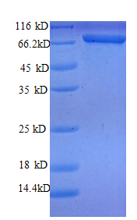
Storage Buffer : | 100mM NaCl,20mM Tris-HCl ,pH8.0 ,50%glycerol
Form : | liquid
Stability & Storage : | Aliquot and store at -20°C or -80°C. Avoid repeated freeze / thaw cycles.

