Rabbit anti-Pig Complement C5a anaphylatoxin polyclonal Antibody
Catalog Number: CSB-PA003995YA01PI
Synonym Names | C5
Product type | Primary antibodies
Description | Rabbit polyclonal to C5
Clonality | Polyclonal
Isotype | IgG
Reacts with | Pig; Other species are not tested. Please decide the specificity by homology
Conjugate | Non-conjugated
Purity | >95% by Caprylic Acid Ammonium Sulfate Precipitation
Storage buffer | 0.01M PBS, PH 7.4
Storage | Shipped at 4°C Upon delivery aliquot and store at -20°C or -80°C. Avoid repeated freeze.
Form | Liquid
Raised in | Rabbit
Tested applications | ELISA: Use at an assay dependent dilution.  IHC:1:10-1:200 (Recommender dilutions)
Images | Immunohistochemistry  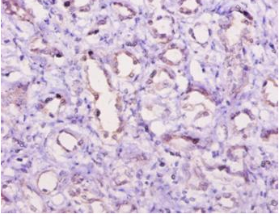  Immunohistochemistry of paraffin-embedded human kidney using CSB-PA003995LA01PI at dilution of 1:10
Function | Derived from proteolytic degradation of complement C5, C5 anaphylatoxin is a mediator of local inflammatory process. It induces the contraction of smooth muscle, increases vascular permeability and causes histamine release from mast cells and basophilic leukocytes. C5a also stimulates the locomotion of polymorphonuclear leukocytes (chemokinesis) and direct their migration toward sites of inflammation (chemotaxis).
References | [1] "Three-dimensional structure of porcine C5adesArg from 1H nuclear magnetic resonance data."Williamson M.P., Madison V.S.Biochemistry 29:2895-2905(1990).  [2] "Identification of classical anaphylatoxin as the des-Arg form of the C5a molecule: evidence of a modulator role for the oligosaccharide unit in human des-Arg74-C5a."Gerard C., Hugli T.E.Proc. Natl. Acad. Sci. U.S.A. 78:1833-1837(1981).  [3] "Amino acid sequence of the anaphylatoxin from the fifth component of porcine complement."Gerard C., Hugli T.E.J. Biol. Chem. 255:4710-4715(1980).

