Rabbit anti-Chicken anemia virus apoptin polyclonal Antibody
Catalog Number: CSB-PA860325DA01CID
Synonym Names | Apoptin,VP3
Product type | Primary antibodies
Description | Rabbit polyclonal to VP3
Clonality | Polyclonal
Isotype | IgG
Reacts with | Chicken; Other species are not tested.Please decide the specificity by homology
Conjugate | Non-conjugated
Purity | >95% by Caprylic Acid Ammonium Sulfate Precipitation
Storage buffer | Preservative: 0.03% Proclin 300  Constituents: 50% Glycerol, 0.01M PBS, PH 7.4
Storage | Shipped at 4°C Upon delivery aliquot and store at -20°C or -80°C. Avoid repeated freeze.
Form | Liquid
Raised in | Rabbit
Tested applications | ELISA: Use at an assay dependent dilution.  WB:1:500-1:5000  (Recommender dilutions)
Positive WB detected in | Chicken anemia virus GST-Apoptin fusion protein
Images | Western blot  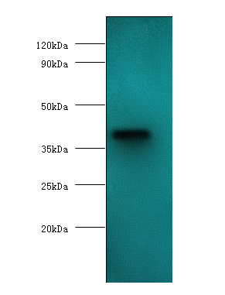  All lanes: Chicken anemia virus apoptin polyclonal antibody at 2µg/ml+GST-Apoptin fusion protein at 0.4µg.  Secondary  Goat polyclonal to Rabbit IgG at 1/10000 dilution  Predicted band size : 40 kDa  Observed band size: 40kDa
Function | May act as transcriptional regulator. Induces apoptosis in infected cells. Element of infectious replication cycle.
References | [1] "Identification of a 24 kDa protein expressed by chicken anaemia virus."  Douglas A.J., Phenix K., Mawhinney K.A., Todd D., Mackie D.P., Curran W.L.  J. Gen. Virol. 76:1557-1562(1995).  [2] "Characterization of viral DNAs from cells infected with chicken anaemia agent: sequence analysis of the cloned replicative form and transfection capabilities of cloned genome fragments."Meehan B.M., Todd D., Creelan J.L., Earle J.A.P., Hoey E.M., McNulty M.S.Arch. Virol. 124:301-319(1992).  [3] "Characterization of cloned chicken anemia virus DNA that contains all elements for the infectious replication cycle."Noteborn M.H.M., de Boer G.F., van Roozelaar D.J., Karreman C., Kranenburg O., Vos J.G., Jeurissen S.H.M., Hoeben R.C., Zantema A., Koch G., van Ormondt H., van der Eb A.J.J. Virol. 65:3131-3139(1991).

